NAME: TUFAIL AHMED B
ROLL NO: 241901119
EXPERIMENT – 6
EXTRACTION OF BROWSER ARTIFACTS
AIM
To extract and examine browser artifacts using forensic tools.
PROCEDURE
- Use ChromeHistoryView to examine Google Chrome browsing history.
- Open the tool and view the list of visited web pages.
- Observe the URL, page title, visit date and time, and number of visits.
- Examine the typed count, referrer, and visit ID details.
- Use ChromeCacheView to examine files stored in the Chrome cache folder.
- Observe the URL, content type, file size, and last accessed time of cached files.
- Use IEHistoryView to examine the browsing history stored by Internet Explorer.
- Use IECacheView to examine cached files and their details, including filename, URL, last accessed time, and file size.
- Analyze the collected browser artifacts for forensic investigation.

OBSERVATION
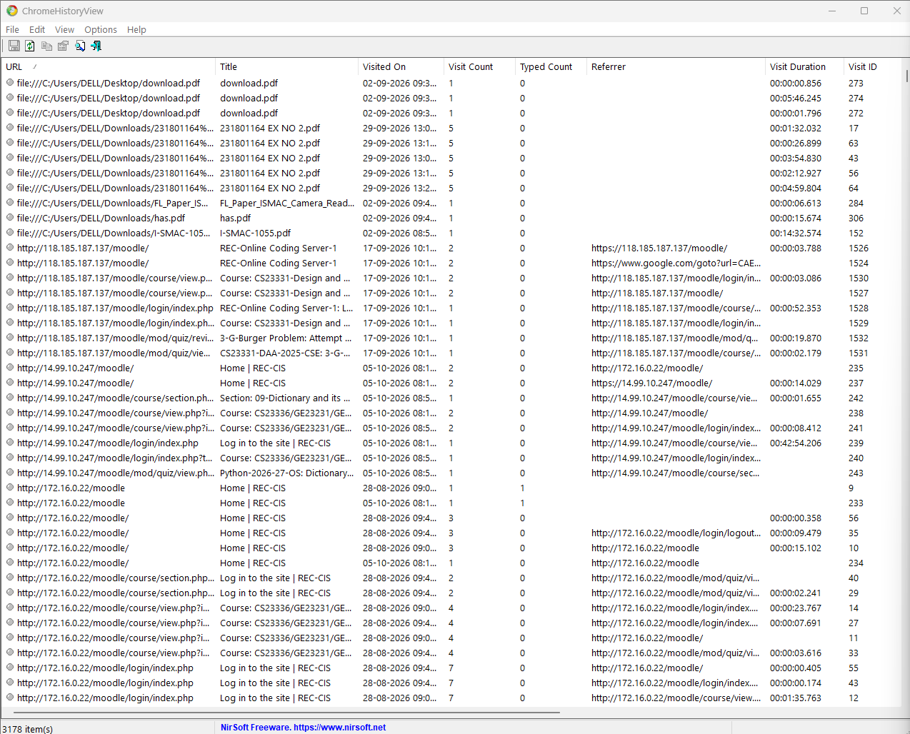

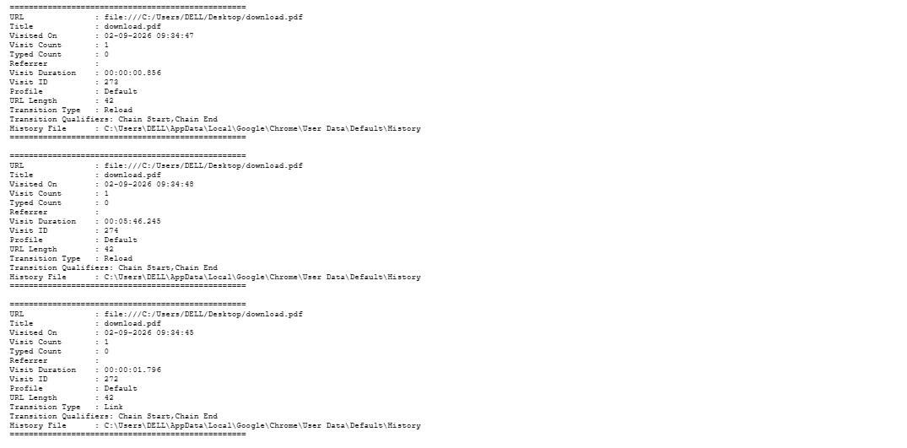

RESULT
Thus, browser artifacts were examined using forensic tools to analyze browsing history and cached data.

